* **Mermaid/Siren**

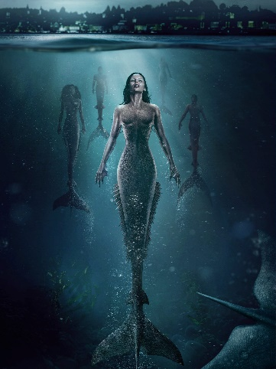

* **Kraken**

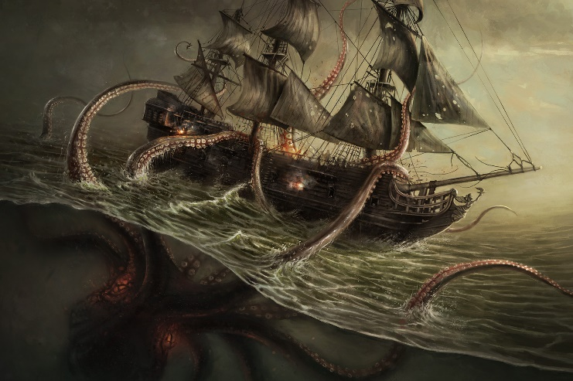

* **Leviathan**

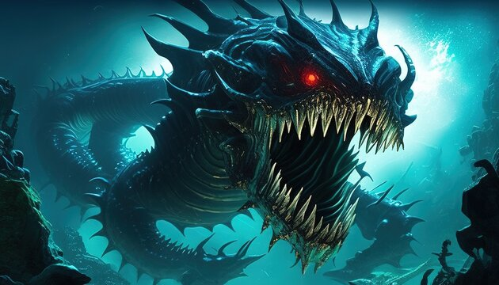

* **Charybdis**

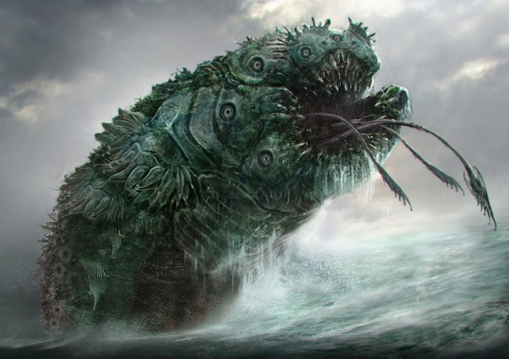

* **Scylla**

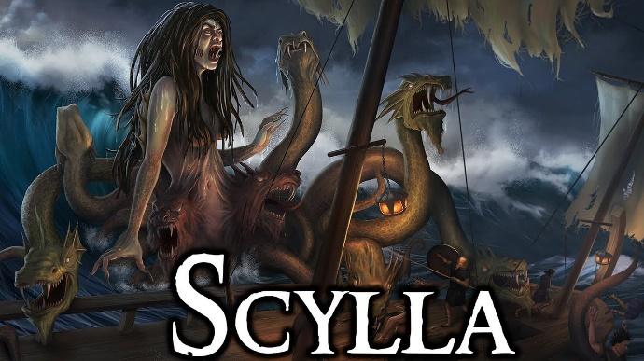

* **Jormungandr/World serpent**

* **Sea serpent**

* **Loch ness monsterA close-up of a monster

  Description automatically generated**
* **HydraA group of snakes with their heads open

  Description automatically generated**
* **Cthulhu**

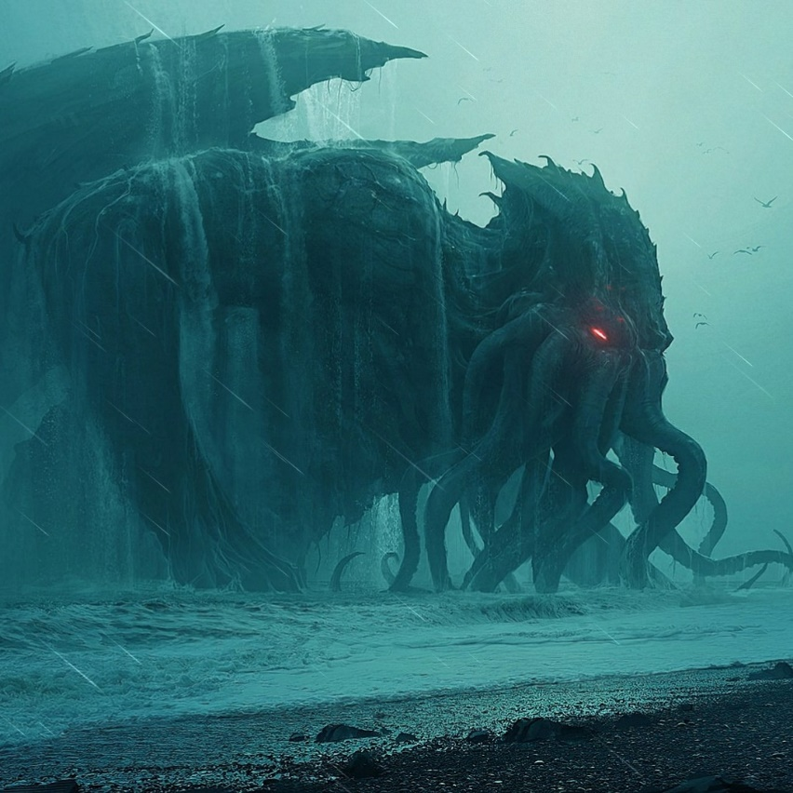

* **Aspidochelone**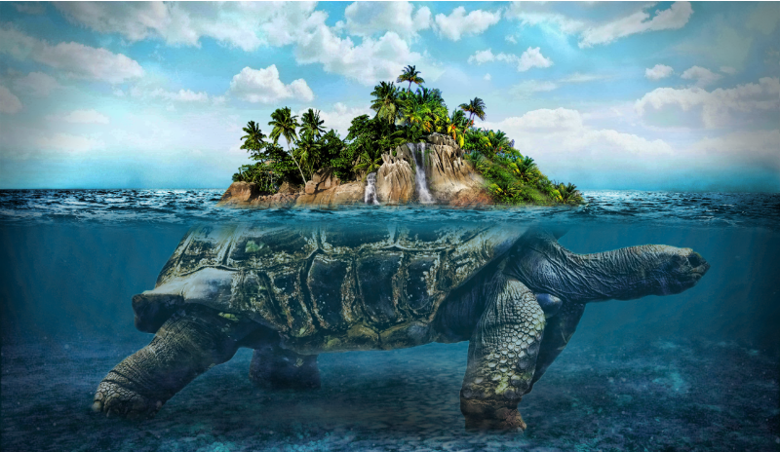
* **Lusca**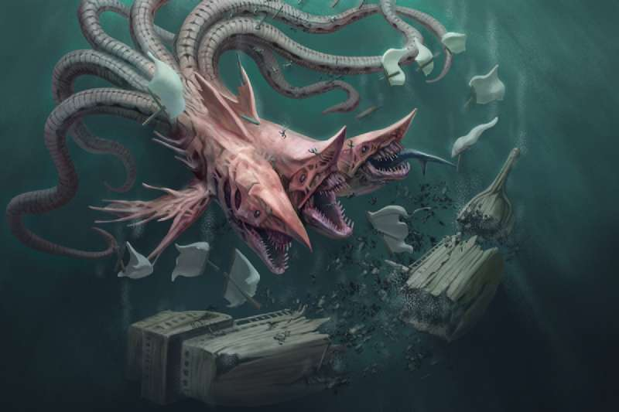
* **Makara**

* **Hippocamp**

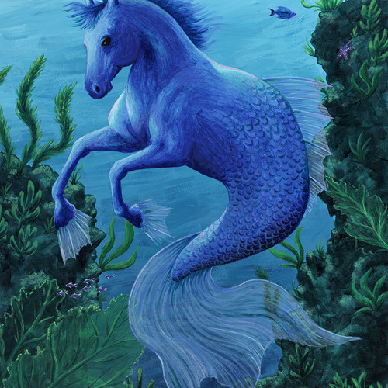

* **Hafgufa**

* **Grindylow**

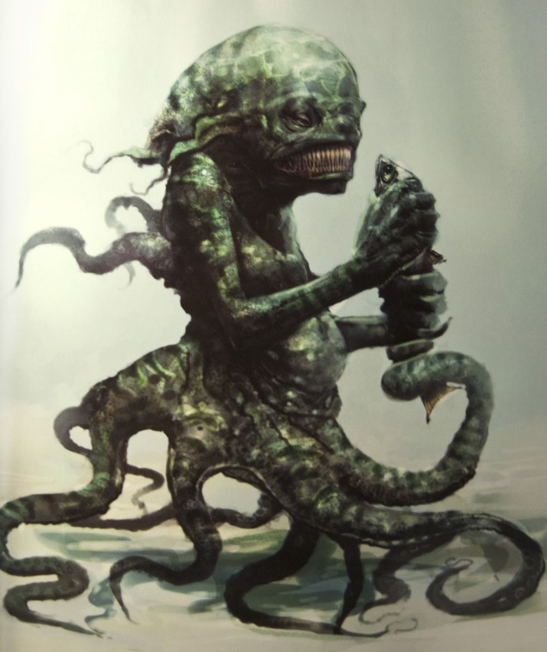

* **Selkie (half human half fish)**

* **Terrible Dogfish**

